How to Find Fast-Review Q1/Q2 Journals in Engineering & Applied Sciences Without Sacrificing Impact
A practical guide for researchers who need to publish quickly, and well
Every engineering researcher knows the feeling: the experiments are done, the manuscript is polished, and then the waiting begins. Six months for a first decision is not unusual in some journals. If you are a PhD student facing a graduation requirement, an early-career researcher with a tenure or grant clock ticking, or a lab chasing a funding deadline, that delay is costly.
The good news is that speed and impact are not opposites. Many reputable Q1 and Q2 journals in engineering and applied sciences have efficient editorial systems. The trick is knowing how to find them, how to verify them, and how to avoid the “fast but predatory” trap. This guide walks through a repeatable process.

1. First, Understand What “Q1/Q2” Actually Means
Quartiles rank journals within a subject category by an impact metric. A Q1 journal sits in the top 25% of its category, and Q2 in the 25-50% band. Two main systems are used:
- Journal Citation Reports (Clarivate): quartiles are based on the Journal Impact Factor (JIF) within Web of Science categories [2], [4].
- SCImago Journal Rank (SJR, Scopus data): quartiles are based on SJR, which weights citations by the prestige of the citing journal. It is free to use [1], [3].
Important: a journal can be Q1 in one category and Q2 or Q3 in another, and quartiles change every year. Always check the category that matches your topic, and use the most recent data release.

2. The Six-Step Workflow
Rather than guessing or relying on colleagues’ anecdotes, follow a structured funnel. Figure 1 summarises the process; the sections below explain each step.
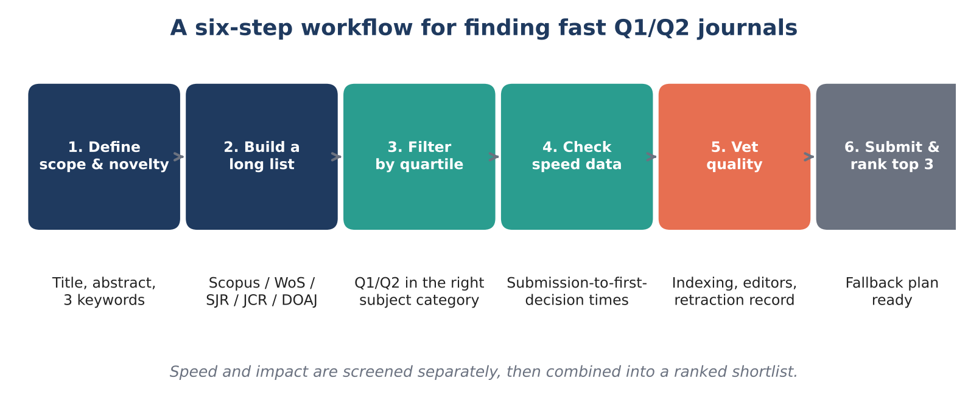
Figure 1. Six-step workflow for building a shortlist of fast, high-quality journals.

Step 1: Define your scope and contribution
Write a two-sentence summary of what is new in your work and pick three to five keywords. Be honest about whether your contribution is a fundamental advance, an application, or a case study. Applied and incremental work often finds faster, more welcoming homes in applications-focused journals than in flagship titles.

Step 2: Build a long list
Use several sources rather than one:
- SCImago (scimagojr.com): filter by subject area (e.g., Engineering, Materials Science, Energy) and by quartile [3].
- Scopus / Web of Science “Find a journal” tools: paste your abstract and get matches by topic.
- Publisher matchers: Elsevier JournalFinder, Springer Journal Suggester, IEEE Publication Recommender, Wiley Journal Finder and similar tools.
- Your own reference list: the journals you cite most are natural candidates, because they already publish on your topic.
- DOAJ: useful for verifying open-access titles [12].

Step 3: Filter by quartile in the right category
Narrow the long list to Q1 and Q2 journals in your closest subject category. Where possible, confirm the quartile in both SJR and JCR. A journal that is strong in both is a safer bet for hiring and promotion committees.

Step 4: Collect real speed data
This is where most researchers stop too early. Publication delays vary widely between journals and fields [5], [7], and a journal’s home page rarely tells the full story, so combine several signals:
- Journal “About” or “Metrics” page: many publishers (Elsevier, Springer Nature, MDPI, Frontiers, Wiley) now display median or average “time to first decision” and “submission to acceptance”.
- Published articles: each paper lists received, revised, and accepted dates. Sample 15–20 recent papers and calculate the gaps yourself, an approach used in published studies of publishing delay [5], [6]. This is the most honest data you can get.
- Review-time aggregators and community reports: sites such as SciRev collect author-reported review times. Treat them as directional, not definitive [8].
- Special issues and fast-track options: these can shorten timelines but check that the same rigorous review applies.
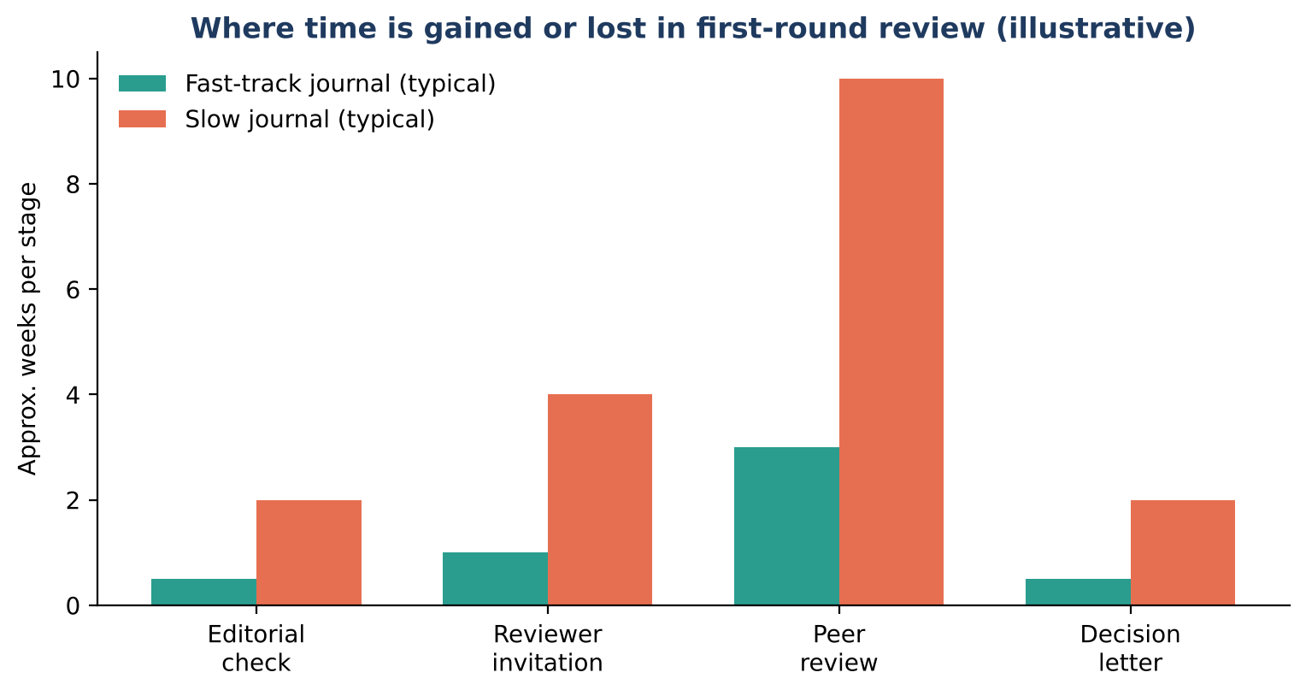
Figure 2. Typical places where review time is gained or lost (illustrative ranges, not measured data).
As Figure 2 suggests, most of the difference between fast and slow journals comes from two places: how quickly editors secure reviewers, and how long the review window lasts; studies of the author’s perspective confirm that review duration differs substantially between journals [6], [7]. Journals with active handling editors and shorter review deadlines tend to publish more predictably.

Step 5: Vet for quality and legitimacy
Fast does not mean careless, but some predatory outlets exploit the demand for speed [9], [10]. Before submitting, check:
- The journal is indexed in Scopus or Web of Science (verify directly in the index, not by the badge on the journal website).
- An identifiable editorial board with real affiliations and publication records.
- Transparent peer-review policy, ethics statements, and a clear retraction process (see COPE membership and guidelines [11]).
- No guarantees of acceptance within days, no unsolicited email invitations, and no hidden fees. The “Think. Check. Submit.” checklist is a useful companion [13].
- Check the journal against current lists of delisted or discontinued titles, since indexing status can change.

Step 6: Rank your top three and plan a fallback
Combine your findings into a weighted score (Figure 3 offers a starting template). Choose a first-choice journal, a second, and a safe third, and prepare your cover letter and formatting so that a transfer takes days rather than weeks.
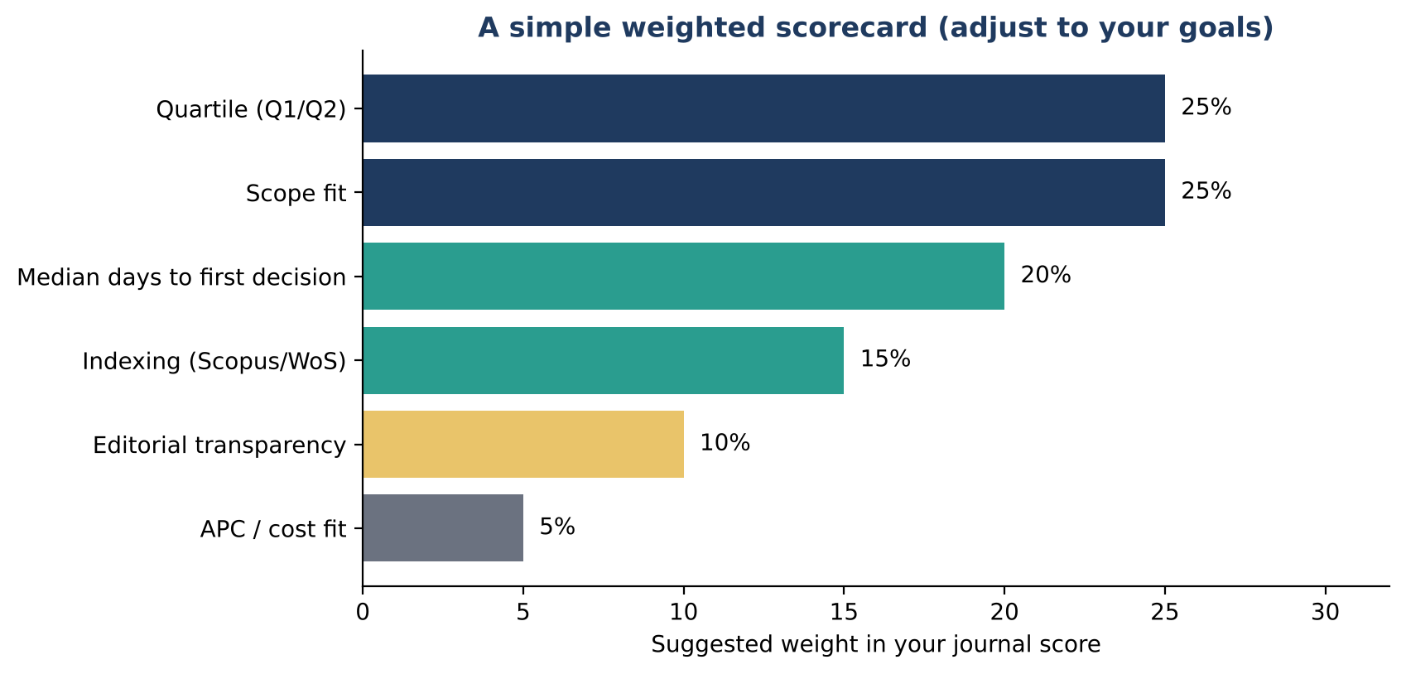
Figure 3. Example scorecard weights for ranking candidate journals. Adjust to your own priorities.

3. Mapping the Speed–Impact Trade-Off
It helps to place candidate journals on a simple map. The goal is the upper-right quadrant: journals that are both fast and well regarded. Journals that are prestigious but slow can still be the right choice for a major result, but should be planned for in advance. The lower-right quadrant is where predatory or low-rigor outlets tend to appear [9], [10].
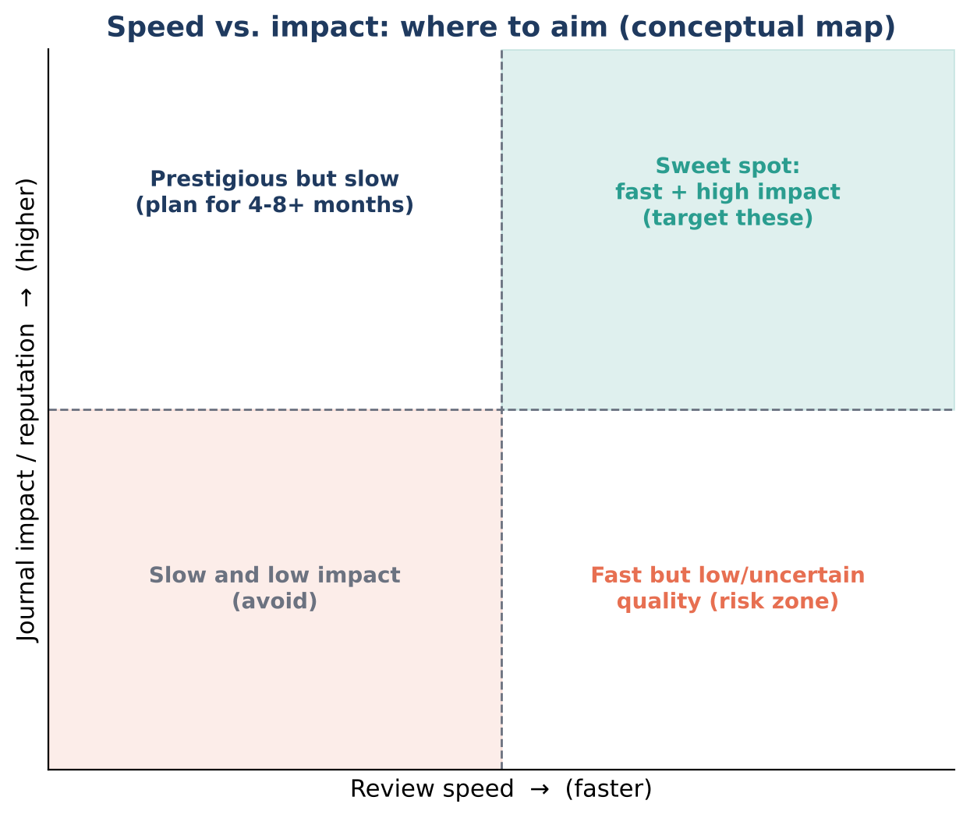
Figure 4. Conceptual speed-vs-impact map for positioning candidate journals.

4. Journal Types That Often Balance Speed and Impact
Without naming a “best” list (quartiles shift every year), these categories commonly offer efficient review while keeping Q1/Q2 standing in engineering and applied sciences:
Journal type | Typical strengths | What to watch
Large multidisciplinary or broad-scope engineering journals (e.g., IEEE Access, Scientific Reports) | High volume, structured workflows, wide readership | Broad scope means competition for attention; check topic-specific quartile
Application-focused society and publisher journals (e.g., IEEE Transactions letters, Elsevier “Results in…” and “Case Studies in…” series) | Welcome applied and incremental work, often clear review targets | Some titles are newer; verify indexing and category quartile
Letters and rapid-communication journals | Short format, quick first decisions | Strict length limits and novelty expectations
Open-access journals with published timelines (e.g., MDPI, Frontiers titles) | Transparent time-to-decision data, fast turnaround | Article processing charges; review quality varies by title, so judge each journal individually
Traditional flagship journals | Highest prestige and visibility | Longer reviews, higher desk-rejection rates

Note: the examples above are illustrations of categories, not endorsements. Always confirm the current quartile, indexing status, and review metrics before submitting.

5. Tips to Speed Up Your Own Review
Journals control some of the timeline, but you control more than you think:
- Avoid desk rejection: match the scope, follow the author guidelines exactly, and state your novelty in the first paragraph of the abstract and cover letter.
- Suggest qualified reviewers: provide four to six reviewers with institutional emails, no conflicts of interest, and relevant publications. This reduces the time editors spend finding them.
- Submit a complete package: figures at proper resolution, a data availability statement, ethics statements, and a clean reference list prevent technical-check delays.
- Pre-submission polish: language editing and a colleague’s read can avoid a major-revision round.
- Respond to reviewers quickly and thoroughly: a point-by-point response with tracked changes often shortens the revision cycle.
- Use preprints where allowed: posting on arXiv, TechRxiv, or similar establishes priority while you wait.

6. Red Flags vs. Green Flags
Red flags (proceed with caution) | Green flags (generally reassuring)
Guaranteed acceptance or “review in 3 days” | Median review times published with methodology
Unsolicited emails inviting you to submit | Indexed in Scopus/WoS, verified at the source
Vague scope covering all of science | Clear aims and scope aligned with your topic
Fake or copied impact factor claims | Quartile confirmed in SJR/JCR for the correct category
No named editors or unverifiable board members | Transparent editors and peer-review policy, COPE alignment [11]
Fees requested before peer review is described | Clear APC policy with waivers where applicable

7. A Quick Checklist Before You Click “Submit”
- Journal is Q1 or Q2 in my specific subject category (latest year).
- Indexed in Scopus and/or Web of Science, verified directly.
- I sampled recent papers and calculated received-to-accepted times.
- Scope match is strong; I have read at least three recent articles.
- Costs (APC, colour charges) fit my budget or funding.
- Manuscript follows the template and includes all required statements.
- I have a second and third choice ready.

Final Thoughts
Finding a fast-review Q1 or Q2 journal is less about luck and more about method. By screening for quartile, gathering real turnaround data, vetting legitimacy, and preparing a polished submission, you can often shave months off your timeline without compromising on reputation. Treat speed as one criterion among several, and let your research goals, whether career milestones or maximum visibility, decide how much weight it deserves.
Have a favourite fast and reputable journal in your field? Share your experience with fellow researchers, because community knowledge is one of the best resources we have.

References
[1] González-Pereira, B., Guerrero-Bote, V. P., & Moya-Anegón, F. (2010). A new approach to the metric of journals’ scientific prestige: The SJR indicator. Journal of Informetrics, 4(3), 379–391.
[2] Garfield, E. (2006). The history and meaning of the journal impact factor. JAMA, 295(1), 90–93.
[3] SCImago Lab. SCImago Journal & Country Rank. https://www.scimagojr.com
[4] Clarivate. Journal Citation Reports. https://clarivate.com/academia-government/scientific-and-academic-research/research-funding-analytics/journal-citation-reports/
[5] Björk, B.-C., & Solomon, D. (2013). The publishing delay in scholarly peer-reviewed journals. Journal of Informetrics, 7(4), 914–923.
[6] Huisman, J., & Smits, J. (2017). Duration and quality of the peer review process: The author’s perspective. Scientometrics, 113(1), 633–650.
[7] Powell, K. (2016). Does it take too long to publish research? Nature, 530(7589), 148–151.
[8] SciRev. Author-reported peer review experiences. https://scirev.org
[9] Grudniewicz, A., et al. (2019). Predatory journals: No definition, no defence. Nature, 576(7786), 210–212.
[10] Shamseer, L., et al. (2017). Potential predatory and legitimate biomedical journals: Can you tell the difference? A cross-sectional comparison. BMC Medicine, 15, 28.
[11] Committee on Publication Ethics (COPE). Core practices and guidance. https://publicationethics.org
[12] Directory of Open Access Journals (DOAJ). https://doaj.org
[13] Think. Check. Submit. Choose the right place for your research. https://thinkchecksubmit.org
Please verify each reference (volume, pages, URLs and access dates) against the original source before publishing.
Disclaimer: Journal metrics, quartiles, and review times change frequently. Figures 2 and 4 are conceptual illustrations, not measured data. Verify all details on SCImago, Journal Citation Reports, and the journal’s own website before making decisions.

